Parilla Replacement Pistons
As motors get older and reach maximum bore sizes locating pistons can be problematic especially for the 48 series motors such as the Parillas, BMs and DAPs.

Small End Bearing
Some of the pistons, such as those made by Asso Werke are suitable but may have a 20.0mm wide dimension between the little end shoulders. As the commonly available little end bearing is only 17.0mm the bearing can come partially disengaged from the con-rod, so it is necessary to fit shims or use a wider bearing. These bearings are not commonly available but were manufactured for Honda 125cc trail and motocross bikes some years ago and can be obtained from some stockists of classic motorcycle parts. The appropriate part numbers are 91009-444-004 or 91007-444-004.

One known stockist is Rider Motorcycles in the UK - www.ridersmotorcycles.co.uk .

Piston Heights
Once the bore size exceeds the commonly available piston size of 48.75 it will be necessary to move to the 49 series pistons. Although these are readily available they do have a different gudgeon pin to crown height. The 49 series are approximately 1.7 mm lower. This will mean that the barrel will have to be dropped by a corresponding amount.

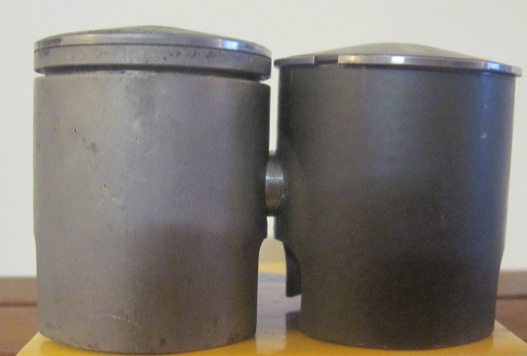

Boost Port
Many of the pistons available will be “TT” style without a boost port window in the front wall. Early TT pistons were identical to boost port pistons except that they did not have the window cut. They still had the reinforced casting marks where the window should be and so are strong enough to have a window cut into them. Later pistons, especially the coated type, do not have this strenghened area and can be substantially weakened if a boost port is cut. Some reports are that even a small hole in the area can be enough to make the piston fail.

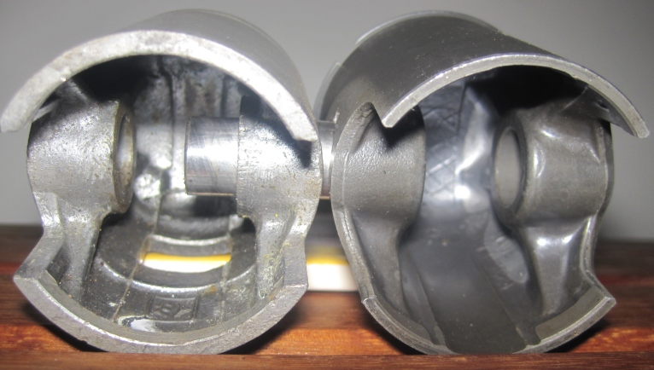

Conrod and Big End Profile
Newer IAME conrods have a different profile across the big end. This can cause interference with the crank cases which will have to be ground to give adequate clearance.

